SYNOVITIS
Boggy/squidgy swelling and tenderness (demonstrated by pain on palpation using just enough pressure to make the examiners nail blanch) indicates active inflammation.
Squeeze test: subtle synovitis
The squeeze test is a useful clinical test to determine subtle synovitis that is not palpable and can be performed at the metacarpophalangeal (MCP) or metatarsophalangeal (MTP) joints as shown in Figure 2. Tenderness elicited with a gentle squeeze is suggestive of synovitis.
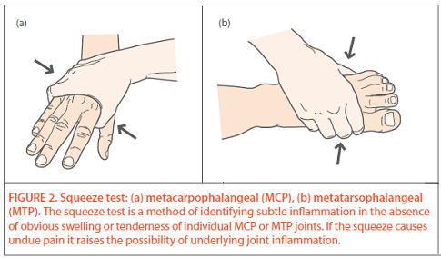

Reference:
Arthitis research UK: The approach to the patient with multiple joint pains, Autumn 2012

