How to do
teledermatology
with iPhone and PowerPDF

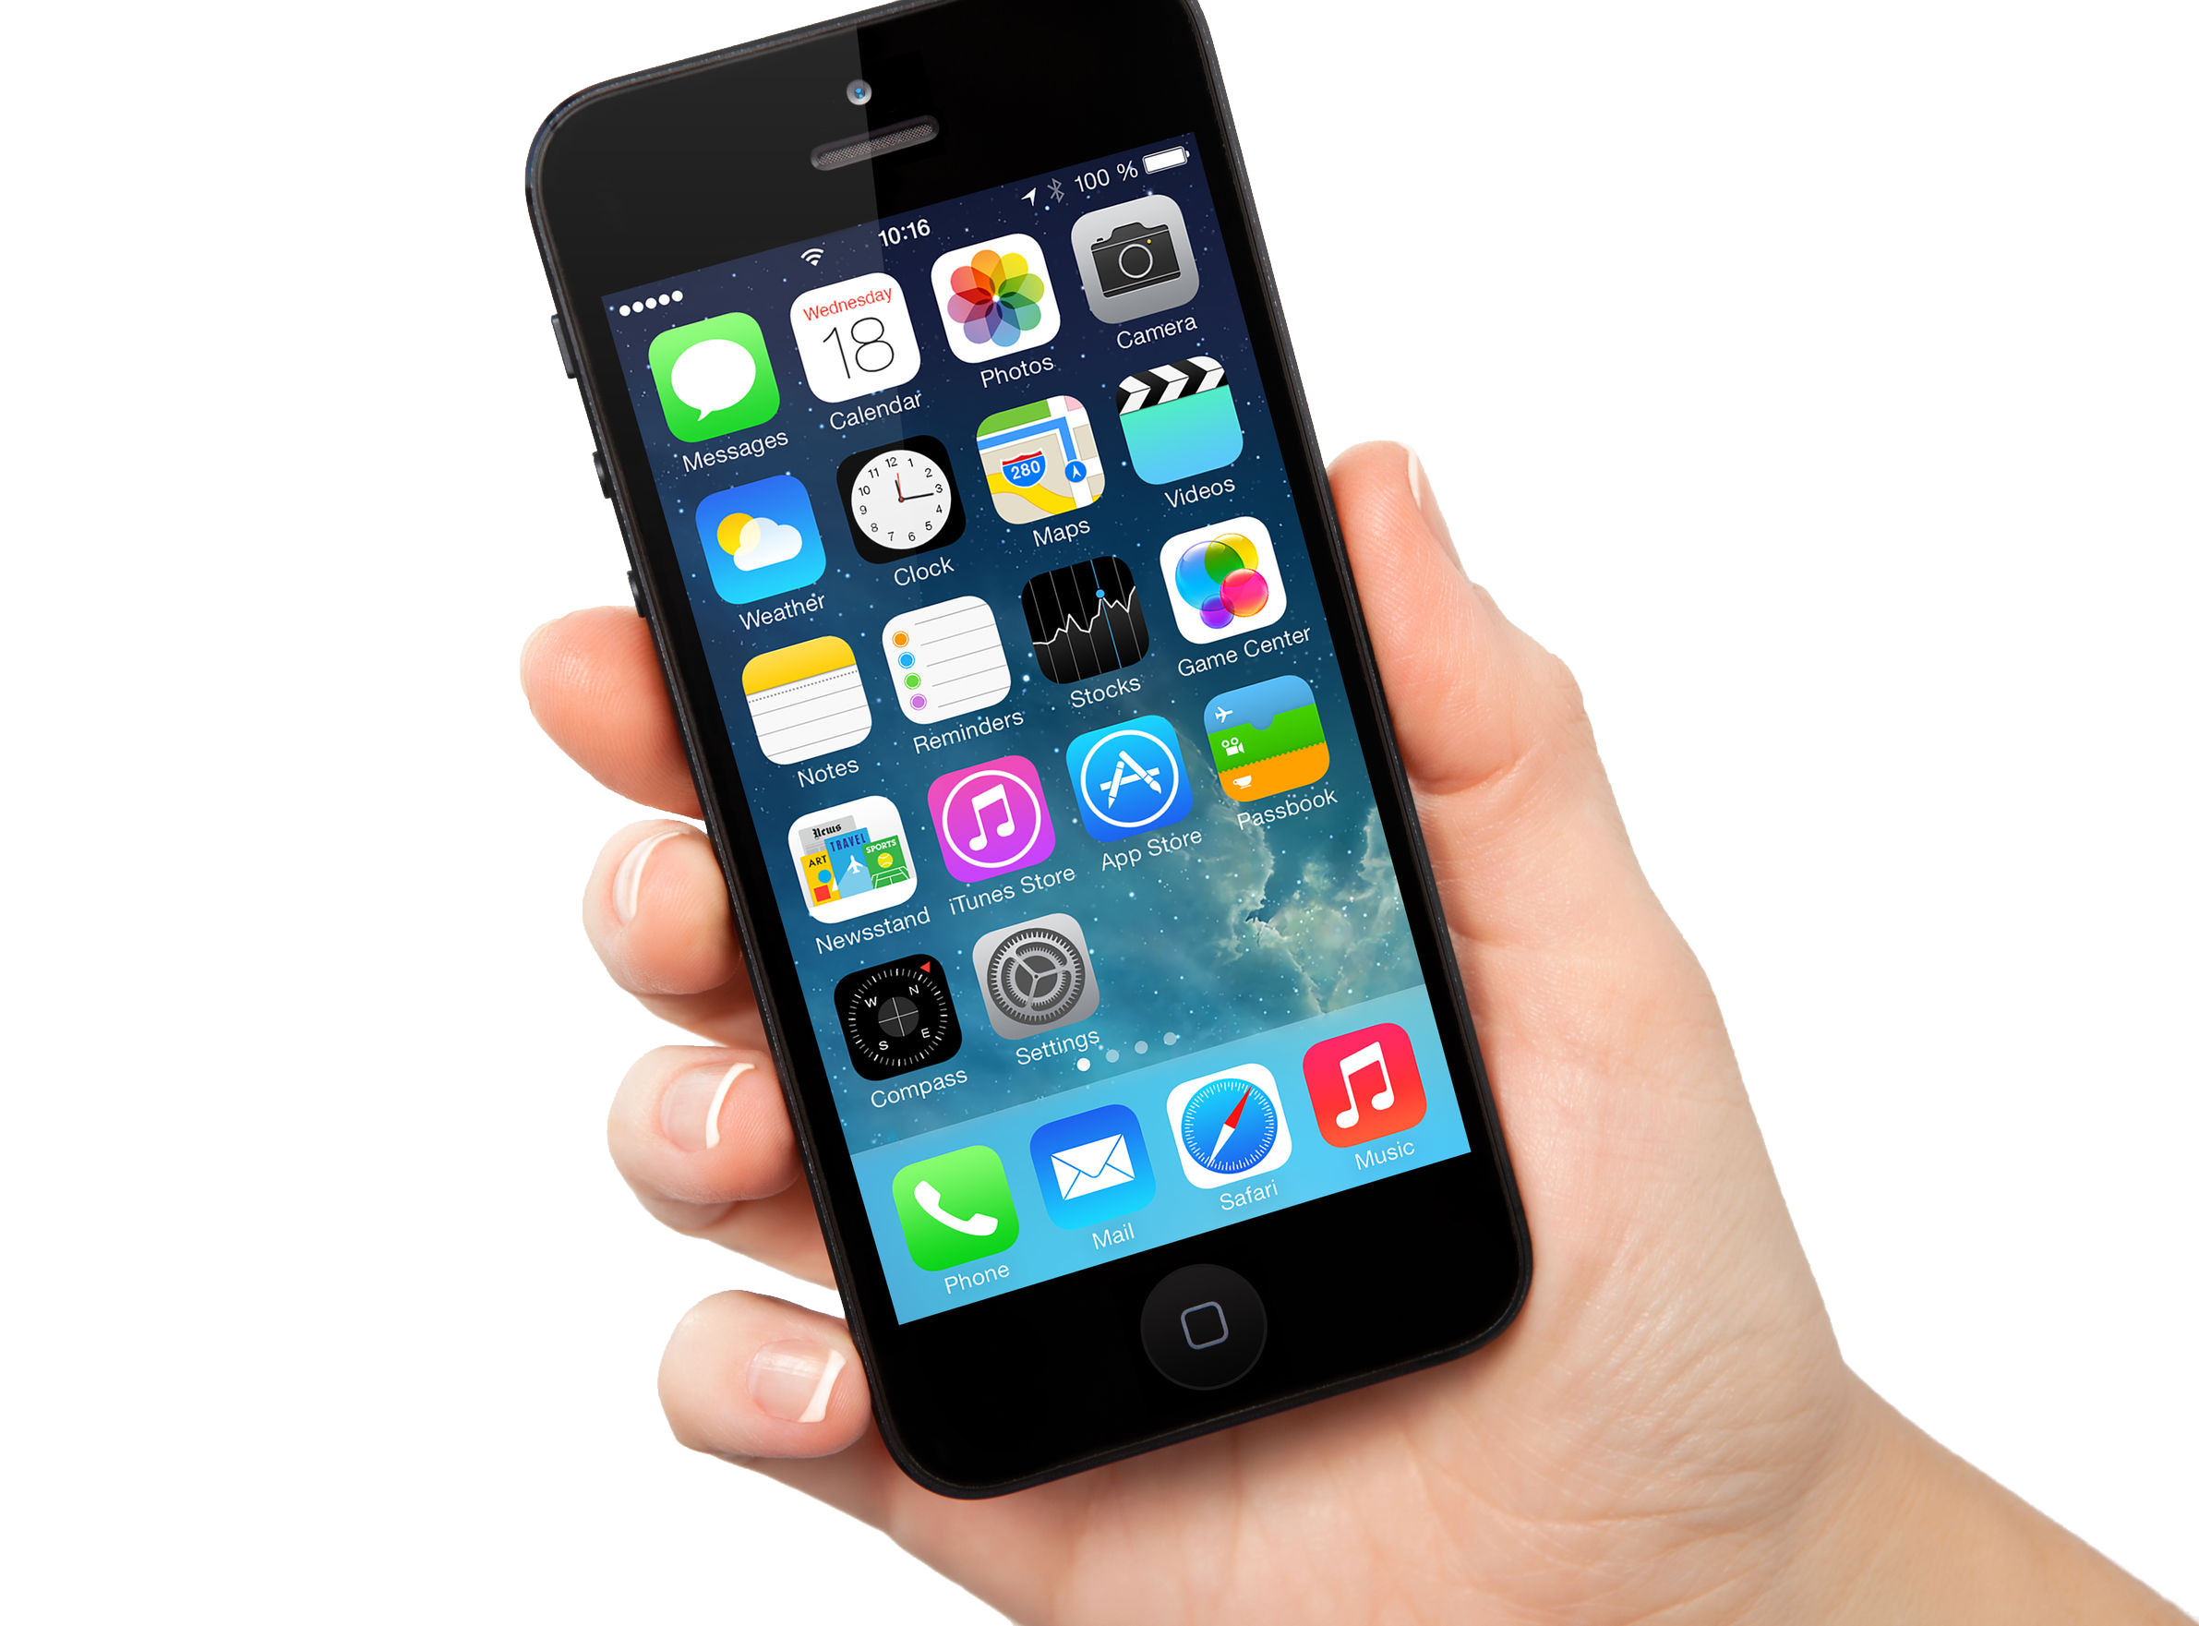

It takes a few minutes of fiddling to set up, but once this is done you should find it quick to use during a consultation and you will be meeting CCG information governance standards.

Using a dedicated free app is the most secure option, as photos taken are stored separately within the app and don’t appear among your personal photos. Because of this you won’t need to deactivate your icloud. There are:

4 Steps to set up your iPhone:

- Brief your practice secretary & obtain their NHS.net email address.
- Ensure your phone is passcode protected and autolocks after 5 minutes
- Download the free app ‘power PDF’ from the app store.
- Add your NHS.net account onto your device

Then only:

3 Steps each time you use it:

- Print, sign and photograph the consent form.
- Photograph the skin and share via email (using WiFi, 3G or 4G)
- Delete photos from your device afterwards

Instructions for each step:

- Ask your practice secretary nicely if they can upload photos that you email to their NHS.net account onto the clinical record and/or to the e-referral system for teledermatology. Keep a note of their email address.

- Add a 4 digit passcode to unlock your homescreen. Go to ‘settings’ > ‘Touch ID & Passcode’. Autolock is under ‘General’.

- Download ‘power PDF’ . Click the app store icon and type ‘power PDF’ into the search bar. You only need the free version of the app (just ignore the adverts!)

- Add your NHS.net email account go to Settings > Mail, Contacts, Calendars > Add Account > Exchange > just enter your email address and password as prompted.

When prompted ONLY sync your mail, not your contacts, calendars and reminders as well.

Going on holiday and don’t want your work email on your phone? Go back to Settings > Mail, Contacts, Calendars > Exchange mail and toggle mail off. It can be toggled back on whenever you need it again.
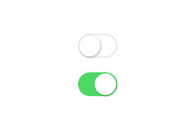
Mail off

Mail on
If you forget your NHS mail password, request a password reset by contacting the IT helpdesk on 01209 88 1717. DO NOT KEEP GUESSING. Entering an incorrect password 8 times will wipe your device and restore factory settings. Routine password update is every 90 days.

Now you’re ready to use your iPhone to do teledermatology with the patient in the room (although we suggest a few practice runs first!)

- Gain written consent. You can print off the version at the end of this document, or copies can be found on the RMS website.

Why not print off a few forms to keep in a drawer for next time.
This helps to protect both you and the patient, particularly as you are using your own device for potentially sensitive material.

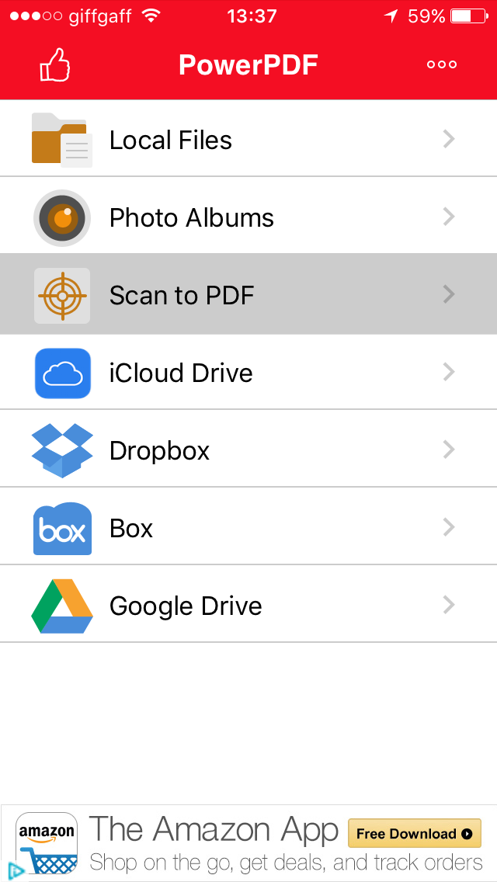
- To take a photo:

  - Open the PowerPDF app ➔

  - Select ‘scan to PDF’

  - Select ‘colour’

  - Position and take photo by pressing the icon at the bottom.

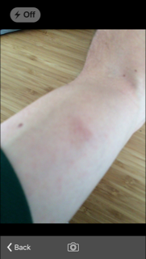

Ensure adequate lighting (use the examination lamp) and that the subject is in focus (image has crisp edges).
It’s good to take at least one close up for detail and a distance shot for distribution. Placing a ruler in shot can be useful for scale.

  - To take more photos select ‘rescan’

  - When you’re done select ‘finish’

  - You’ll then be prompted to name the file – always use the patient number or NHS number and NOT their name.

  - Your photos will appear in the list below. Select the ones you want to use, including your consent form photo. (Selected photos will be ticked red)

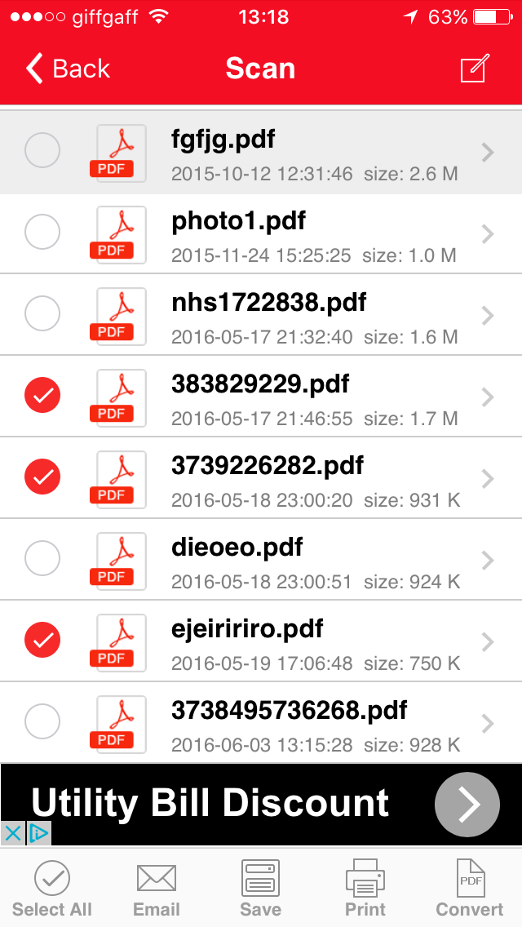

  - Press ‘Email’ at the bottom of the screen and choose ‘without annotations’.

  - In the ‘to’ field, type the nhs.net address of your practice secretary

  - In ‘from’ scroll down to select your NHS.net address

  - In ‘subject’ put the patients NHS or patient number only. (Not their name)

  - Click ‘send’ (top right). Choose ‘actual Size’. (up to 5MB allowed – in practice you’re unlikely to exceed this).

5MB is the maximum size for uploads to the e-referral system. In practice you’re unlikely to exceed this.

- Delete patient photos afterwards.
  - Back on the ‘Scan’ screen you can see your list of photos. Swipe left to reveal a ‘delete’ button.

Happy snapping!
We hope this has been helpful.

More information and contact details can be found on the RMS website > dermatology > teledermatology.
Consent Form for Teledermatology

1. PATIENT’S NHS number……………………………………………..………………………

I agree to have a digital photograph taken
Using a digital camera YES ☐ NO ☐
Using a smartphone camera YES ☐ NO ☐
- To be stored in my medical records
- To be shared electronically with doctors at the hospital so that they can advise my GP on the diagnosis and treatment of my skin problem
- To be used for the education and training of other doctors. Please tick here if you wish to opt out of this ☐

Patient Signature. ………………………. ……………………....…….. Date …………........

OR

Signature and name of next of kin/carer on patient’s behalf……………………………………………………………………………………………………

Your feedback is valuable. If you would be happy for us to send you one text message afterwards with a link to tell us what you think please write your mobile telephone number:………………………………………………………………

2. DOCTOR’S NAME…………………………………………………………………………………….

If using my own smartphone camera I agree to managing this data securely in accordance with the Data Protection Act requirements published on the RMS website. This includes using nhs.net, deactivating cloud photo sharing (OR using a smartphone app) and deleting the images from my device afterwards. All data and images will be held confidentially and only used for clinical care. The patient has the right to object or withdraw consent at any time by advising me of this.

Doctors Signature…………………………………………………………………………………..

What is Teledermatology?

For certain conditions it can replace the need for you to travel to hospital to see a skin specialist. It allows your GP to share photographs and information with the specialist remotely so that you can be cared for nearer to home. It is a new service within Cornwall but has been running successfully for many years in other areas.

